**Assignment 5.1**

1. input_load = LOAD 'empdetails.txt' USING PigStorage(',')

AS(emp_id :int,emp_name:chararray,salary:int,ratings:int);

top_employees = ORDER input_load BY emp_name ASC;

sort = ORDER input_load BY ratings DESC;

top_performers = LIMIT sort 5;

sort = Order top_performers BY ratings DESC;

each_demo = FOREACH sort GENERATE emp_id,emp_name,ratings ;

DUMP each_demo;

OUTPUT



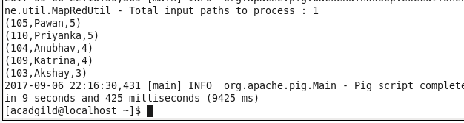

1. input_load = LOAD 'empdetails.txt' USING PigStorage(',')

AS(emp_id :int,emp_name:chararray,salary:int,ratings:int);

emp_salary = ORDER input_load BY salary DESC;

odd_id = FILTER emp_salary BY emp_id % 2 !=0;

limit_demo = LIMIT odd_id 3;

each_demo = FOREACH limit_demo GENERATE emp_id,emp_name,salary ;

DUMP each_demo;

OUTPUT

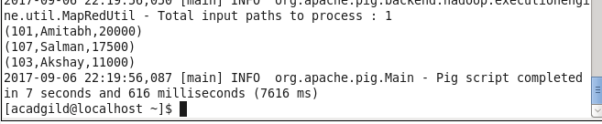

3)

input_load = LOAD 'empdetails.txt' USING PigStorage(',')

AS(emp_id :int,emp_name:chararray,salary:int,ratings:int);

input_expenses = LOAD 'expense.txt' USING PigStorage('\t') AS (id :int, expenses :int);

join_demo = JOIN input_load by emp_id,input_expenses by id;

group_demo = GROUP join_demo BY (id,emp_name);

sum_demo = FOREACH group_demo GENERATE (group.id,group.emp_name), SUM(join_demo.expenses);

flatten_demo = FOREACH sum_demo GENERATE flatten($0),flatten($1);

order_demo = ORDER flatten_demo BY $2 DESC;

limit_demo = LIMIT order_demo 1;

DUMP limit_demo;

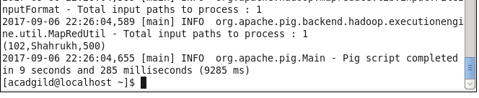

4)

input_load = LOAD 'empdetails.txt' USING PigStorage(',') AS(emp_id :int,emp_name:chararray,salary:int,ratings:int);

input_expenses = LOAD 'expense.txt' USING PigStorage('\t') AS (id :int, expenses :int);

join_demo = JOIN input_load by emp_id,input_expenses by id;

group_demo = GROUP join_demo BY (id,emp_name);

sum_demo = FOREACH group_demo GENERATE (group.id,group.emp_name), SUM(join_demo.expenses);

flatten_demo = FOREACH sum_demo GENERATE flatten($0),flatten($1);

order_demo = ORDER flatten_demo BY $2 DESC;

DUMP order_demo;

